
QUALITY ALERT

Customer: United Date: April 30, 2024
Die: 15142 Colour: Any
Type of Complaint: United REJECTED

Q.A # Q.I.R # CUSTOMER NCR #

Description: United REJECTED due to crooked leg, makes it not fit in the punch.
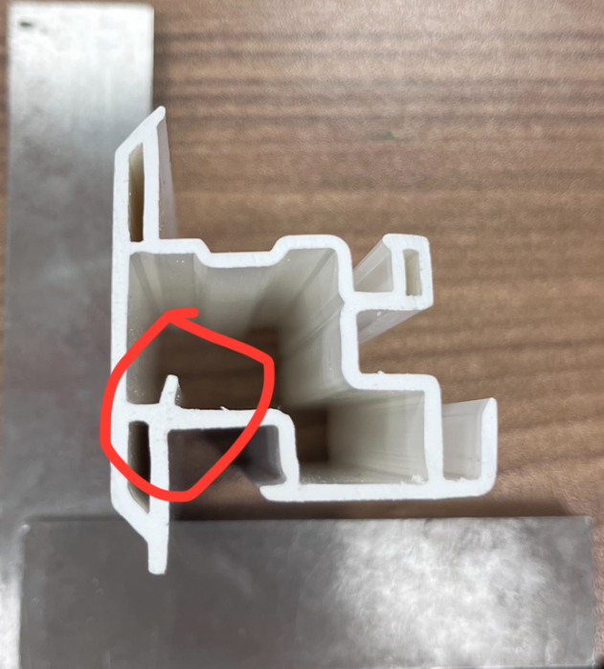
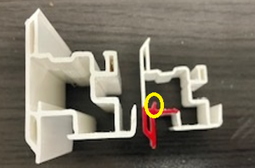

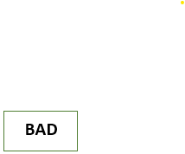



CHECK PUNCH PICTURE TO MAKE SURE THE PUNCH GO THROUGH

BY SIGNING BELOW, YOU ACKNOWLEDGE THE PROBLEM ABOVE AND AGREE TO MONITOR THIS ISSUE IN FUTURE PRODUCTION RUNS.
DAY SHIFT |  | AFTERNOON SHIFT |  | NIGHT SHIFT
NAME | SIGNATURE | NAME | SIGNATURE | NAME | SIGNATURE

